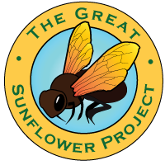
Your name _________________________________________
School garden name :_________________________________

Date ____________________________ MM/DD/YYYY
Start time: : AM / PM
End time : : AM/PM

Total minutes spent observing:_________

My plant type________________________________________________
(such as Lemon Queen Sunflower or Helianthus annuus)

I watched ___________ flowers on that plant.

Number seen: Type of pollinator: NOTES:

__________________ Unknown type of bees

__________________ Bumblebees

__________________ Carpenter bees

__________________ Honey bees

__________________ Other kinds of bees

__________________ Birds

__________________ Butterflies

Please write in other species if you saw

__________________ _______________________

__________________ _______________________

Check this box if you did not see any pollinators
This is the MOST IMPORTANT DATA so, please tell us!

Enter your data at http: //www.GreatSunflower.org

